Project Name: Multi-Channel Customer Behaviour & Marketing Analytics

Contents
1. Power BI dashboard 4
1.1 Summary 4
1.2 Page 1: Customer Overview & Demographic Insights 4
1.2.1 Purpose 5
1.3 Page 2: Multi-Channel Customer Behavior Analysis 5
1.3.1 Purpose 6
1.4 Page 3: Marketing Campaign Performance & Customer Response 6
6
1.4.1 Purpose 7
2. Perform Exploratory Data Analysis 7
2.1 Import necessary libraries 7
2.2 Load the Dataset 7
2.3 Check Dataset Shape 8
8
2.4 Check Column Names and Data Types 8
2.5 Summary Statistics of Numerical Columns 9
2.6 Missing Values - Total and Percentage 10
2.7 Duplicate Check 10
3. Data wrangling/cleansing 10
3.1 Handle Missing Values 10
3.2 Remove Duplicate Rows 11
3.3 Convert Date Columns 11
3.4 Feature Engineering - Create Age Groups 11
11
3.5 Encode Categorical Variables 11
11
3.6 Outlier Detection Using Z-Score 12
12
4. Explore the data by implementing several data visualizations 12
4.1 Import Visualization Libraries 12
4.2 Histogram for Numeric Columns 12
4.3 Count Plot for a Categorical Column 13
4.4 Boxplot to Detect Outliers 14
4.5 Pie Chart for Category Share 15
4.6 Correlation Heatmap 15
4.7 Line Plot for Time Series 16
4.8 Violin Plot 17
4.9 Stacked Bar Chart 18
5. Git Setup 20
5.1 Repository created 20
5.2 Initializes a new local Git repository in your current folder 20
5.3 Git add/commit 21
5.4 git remote add origin https://github.com/Hassankhan86/TTFDS-Project-Multi-Channel-Customer-Behaviour-Marketing-Analytics.git 21
5.5 Git push 22
5.6 Link to the Git Repo 22
6. Use of Machine Learning Techniques 23
6.1 Import Libraries 23
6.3 Data Preprocessing 23
6.4 Split Data into Train/Test Sets 24
6.5. Train Logistic Regression Model 24
6.6. Train Random Forest Classifier 25
6.7 Analyse the results and provide a comparative evaluation using different data mining and visualization methods. 26
6.7.1 Accuracy comparison 26
1. Overall Accuracy 26
2. Class-wise Performance 27
3. Precision vs. Recall for Class 1 27
4. Insights 27
Confusion Matrices 27
6.7.2 Logistic Regression Confusion Matrix: 27
6.7.3 Random Forest Confusion Matrix: 28
7. Quality of the project 29

Part A: Load the data in the tool. Briefly explain the dataset

1. Power BI dashboard

1.1 Summary
This Power BI dashboard provides end-to-end insights into customer demographics, purchasing behaviour across different channels, and marketing campaign effectiveness. The analysis is divided into three interactive pages, each focusing on a key business area.

1.2 Page 1: Customer Overview & Demographic Insights
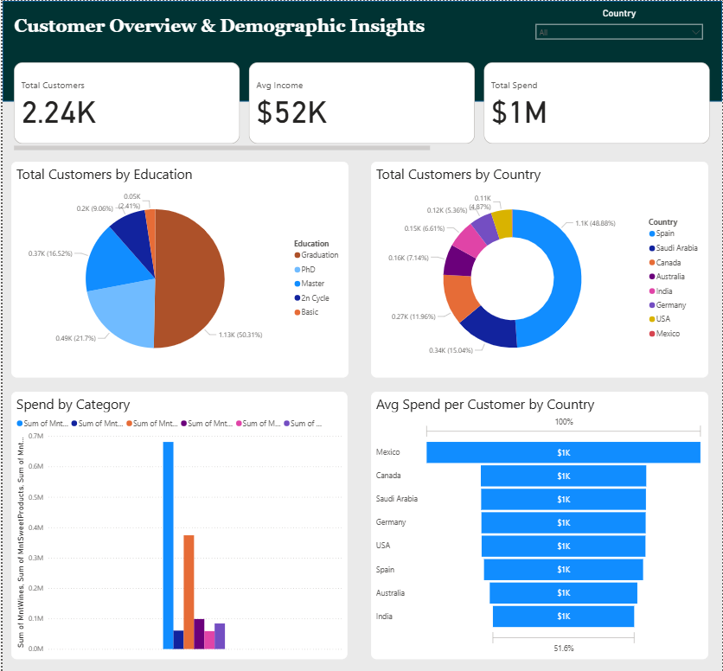
This page gives a high-level understanding of the customer base:
- Total Customers, Avg Income, and Total Spend KPIs show the overall market size and customer value.
- Customers are segmented by education level and country, enabling demographic profiling for targeted marketing.
- The Spend by Product Category visual reveals which product lines generate the most revenue e.g., wines and meat products show strong customer demand.
- Average Spend per Customer by Country helps identify high-value regions for future campaign targeting.

1.2.1 Purpose
This page answers:
- Who are our customers?
- Where are they located?
- Which product categories contribute most to revenue?

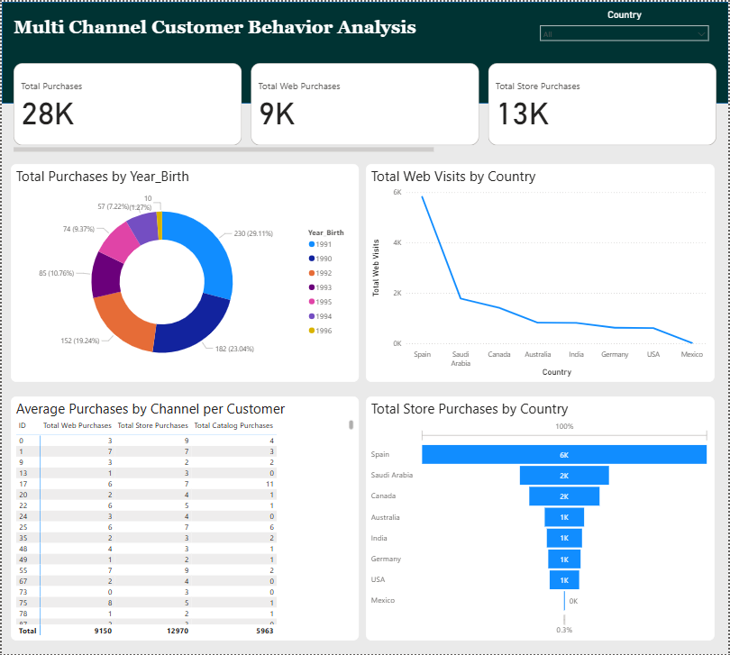
1.3 Page 2: Multi-Channel Customer Behavior Analysis
This page focuses on how customers interact with different purchasing channels, Web, Store, and Catalog.
- KPIs for Total Purchases, Web Purchases, and Store Purchases highlight the dominance or weakness of each channel.
- Purchases by Year of Birth helps identify age-based behavioural differences.
- Web Visits vs Web Purchases shows engagement and conversion rate, indicating how well the website turns visitors into buyers.
- Purchases by Country per Channel reveals regional channel preferences — for example, Spain shows leading store-based engagement.

1.3.1 Purpose
This page answers:
- Which channel performs best?
- Which customer age groups and regions prefer web, store, or catalog shopping?
- How effective are digital interactions?

1.4 Page 3: Marketing Campaign Performance & Customer Response
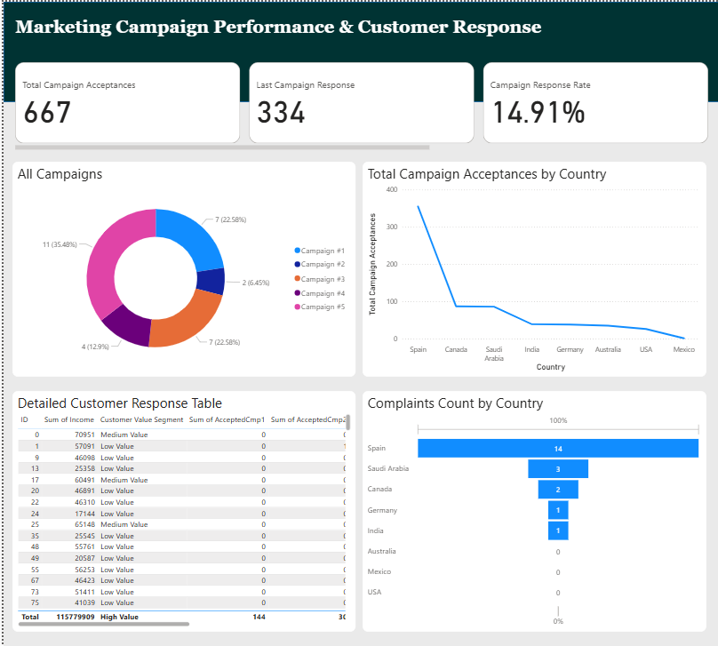

This page evaluates the impact of marketing campaigns and customer satisfaction.
- KPI cards reflect total campaign acceptances, response count, and overall response rate, indicating the success of marketing efforts.
- The campaign donut chart compares the performance of Campaigns 1 to 5, helping identify the most effective promotions.
- Campaign Acceptances by Country highlights regional responsiveness to marketing programs.
- The Customer Response Table allows drill-down by value segment to identify top-responding customer groups.
- Complaints Count by Country helps monitor service quality and identify dissatisfaction trends.

1.4.1 Purpose
This page answers:
- Which campaigns are most successful?
- Which customer segments respond better to offers?
- Where do most complaints come from?

Part B: Perform Exploratory Data Analysis (EDA) using Python

2. Perform Exploratory Data Analysis

2.1 Import necessary libraries
import pandas as pd
import numpy as np

This code imports essential Python libraries: pandas for data manipulation and analysis, and numpy for numerical operations.

2.2 Load the Dataset
df = pd.read_csv('marketing_data.csv')
df.head()

This code uploads the dataset into the Colab environment and loads it into a DataFrame named df to preview the first few rows for initial inspection.
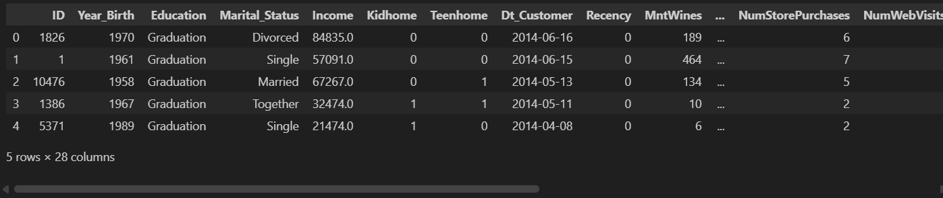

2.3 Check Dataset Shape
print(f"Rows: {df.shape[0]}, Columns: {df.shape[1]}")

This line displays the dataset's dimensions, revealing it contains 2,240 rows and 28 columns, indicating a moderately sized dataset suitable for exploratory analysis
Result:
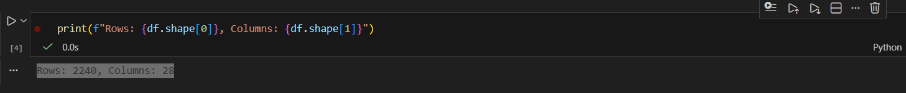

2.4 Check Column Names and Data Types
df.info()

This command provides an overview of the dataset’s structure, including column names, data types, and non-null counts, helping identify missing values and understand the type of data in each column.
Result: 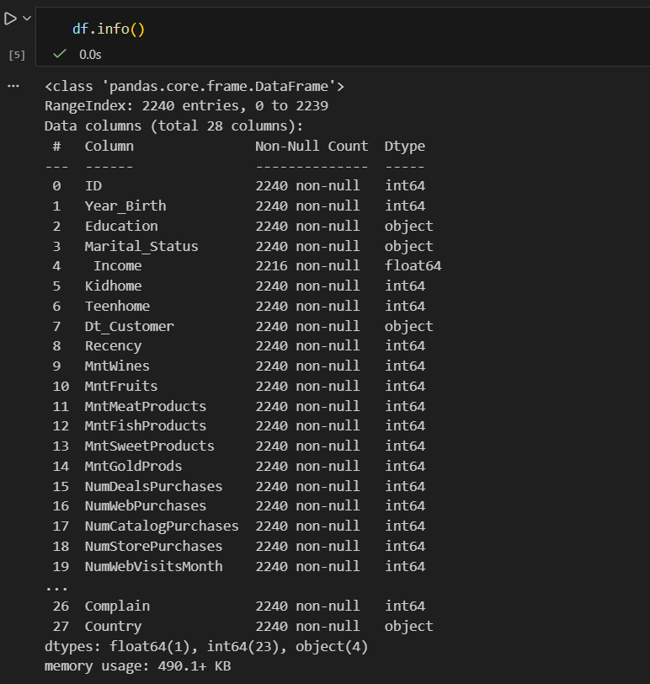

2.5 Summary Statistics of Numerical Columns
df.describe()

This code generates summary statistics (like mean, standard deviation, min, and max) for all numerical columns, offering insights into data distribution and potential outliers.
Result: 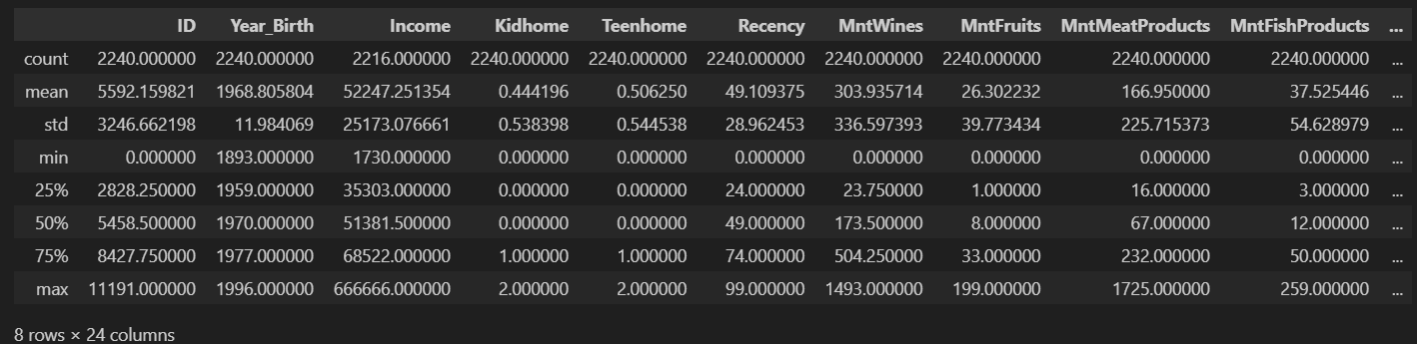

2.6 Missing Values - Total and Percentage
missing = df.isnull().sum()
percent = (missing / len(df)) * 100
missing_df = pd.DataFrame({'Missing Values': missing, 'Percentage': percent})
missing_df[missing_df['Missing Values'] > 0]

This code identifies columns with missing values and calculates their percentage, helping to assess data quality and determine whether imputation or removal is needed.

2.7 Duplicate Check
df.duplicated().sum()

Ensures unique customer records, avoids skewed statistics.

Part C: Data wrangling/cleansing etc. Explain each step

3. Data wrangling/cleansing

3.1 Handle Missing Values
for col in df.select_dtypes(include='object').columns:
df[col] = df[col].fillna(df[col].mode()[0])

This code fills missing values in all categorical (object-type) columns with their most frequent value (mode), ensuring no null values remain in these fields for further analysis.

3.2 Remove Duplicate Rows
print("Duplicates before:", df.duplicated().sum())
df.drop_duplicates(inplace=True)
print("Duplicates after:", df.duplicated().sum())

This code checks for and removes duplicate rows from the dataset to ensure data integrity and prevent skewed analysis due to repeated records.

3.3 Convert Date Columns
df['Year_Birth'] = pd.to_datetime(df['Year_Birth'])
print(df['Year_Birth'])

This code converts the 'Year_Birth' column to datetime format, enabling more accurate date-based operations or age calculations in further analysis.

3.4 Feature Engineering - Create Age Groups
if 'Age' in df.columns:
df['AgeGroup'] = pd.cut(df['Age'], bins=[0, 25, 45, 65, 100],
labels=['Youth', 'Adult', 'Middle-Aged', 'Senior'])
df[['Age', 'AgeGroup']].head()

Creates customer segments for targeted marketing.

3.5 Encode Categorical Variables
df_encoded = pd.get_dummies(df, drop_first=True)
df_encoded.head()

Convert categories into number

3.6 Outlier Detection Using Z-Score
from scipy.stats import zscore
z_scores = np.abs(zscore(df.select_dtypes(include='number')))
outliers = (z_scores > 3).sum(axis=0)
print("Outliers per column:\n", outliers)

Detects unusual values that may distort model learning.

Part D: Build multiple charts using Python

4. Explore the data by implementing several data visualizations

4.1 Import Visualization Libraries
import matplotlib.pyplot as plt
import seaborn as sns

This code imports matplotlib and seaborn for data visualization and sets a clean whitegrid style to enhance the readability of plots.

4.2 Histogram for Numeric Columns
df.hist(figsize=(15, 10), bins=20, color='skyblue', edgecolor='black')
plt.suptitle("Distribution of Numeric Features")
plt.tight_layout()
plt.show()
plt.show()

This code generates histograms for all numeric columns, allowing visual inspection of their distributions, skewness, and potential outliers.
Result:
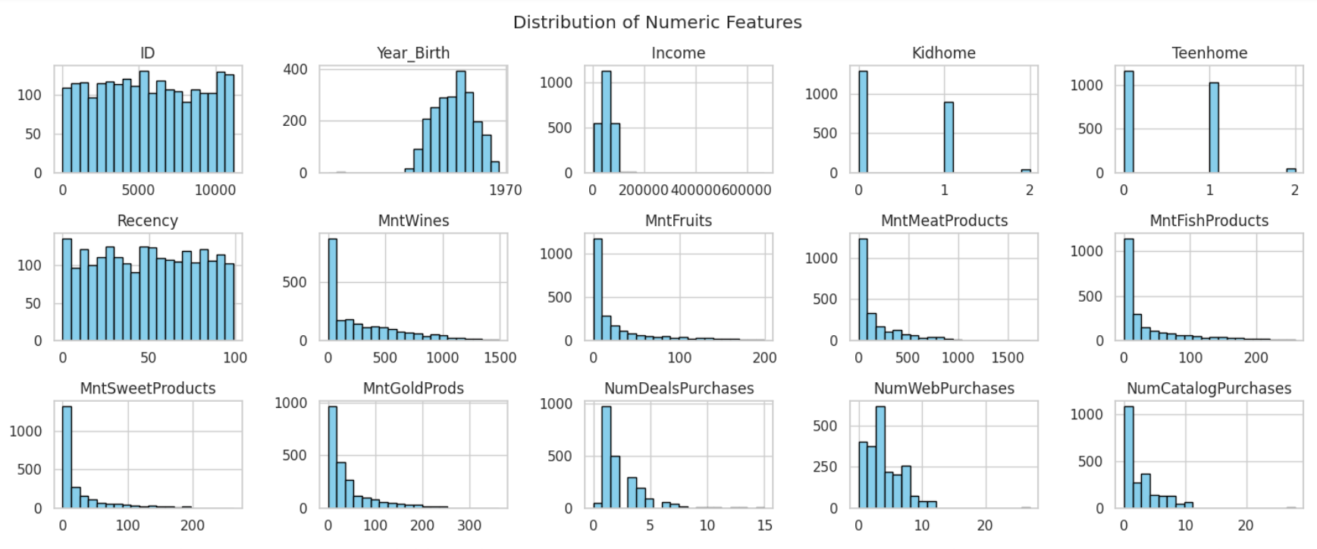

4.3 Count Plot for a Categorical Column
if 'Marital_Status' in df.columns:
sns.countplot(x='Marital_Status', data=df)
plt.title("Marital_Status Distribution")
plt.show()plt.show()

This code creates a count plot for the Marital_Status column, visually representing the distribution of different marital categories in the dataset.
Result:
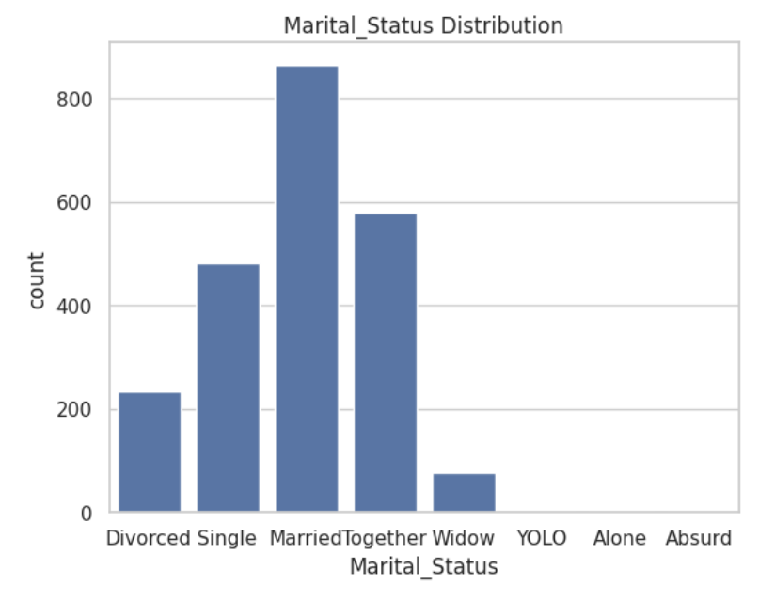

4.4 Boxplot to Detect Outliers
df.columns = df.columns.str.strip()
if 'Income' in df.columns and 'Country' in df.columns:
print("Columns found. Plotting...")
sns.boxplot(x='Country', y='Income', data=df)
plt.title("Income Distribution by Country")
plt.xticks(rotation=45)
plt.show()

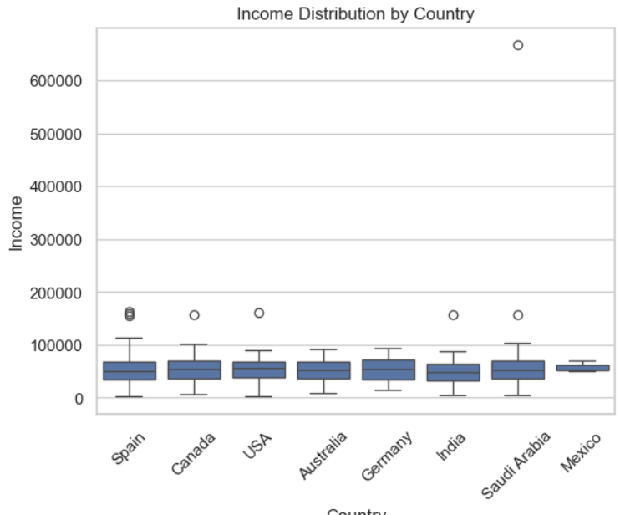
This code generates a boxplot of Income by Country, helping to visually identify outliers and compare income distribution across countries. (Note: The title may need correction if the intent is to show distribution by Country, not Gender.)

4.5 Pie Chart for Category Share
if 'Country' in df.columns:
df['Country'].value_counts().plot.pie(autopct='%1.1f%%', startangle=90, figsize=(6, 6))
plt.title("Country Share")
plt.ylabel('')
plt.show()

This code creates a pie chart showing the proportion of records from each country, providing a quick visual overview of the dataset's geographic distribution.
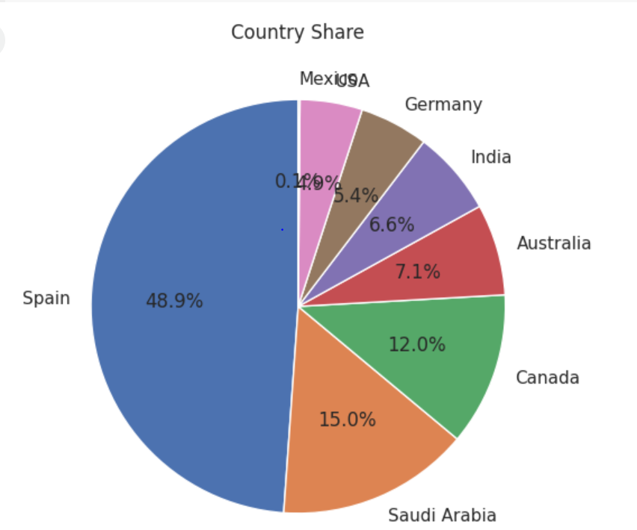
Result:

4.6 Correlation Heatmap
plt.figure(figsize=(12, 12))
sns.heatmap(df.corr(numeric_only=True), annot=True, cmap='coolwarm', fmt=".4f")
plt.title("Correlation Heatmap")
plt.show()

This code generates a heatmap of the correlation matrix for numerical variables, visually highlighting strong positive or negative relationships between features.
Result:
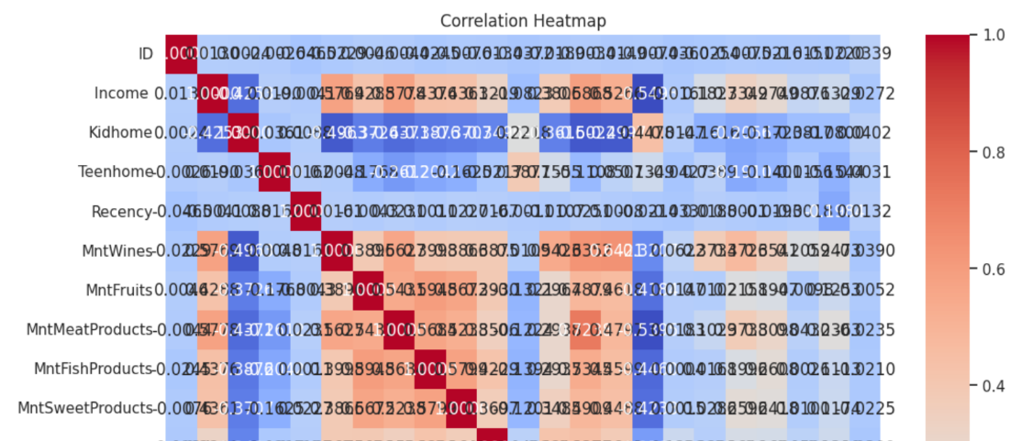

4.7 Line Plot for Time Series
if 'Dt_Customer' in df.columns and 'MntWines' in df.columns:
df['Date'] = pd.to_datetime(df['Dt_Customer'])
df.groupby('Date')['MntWines'].sum().plot(figsize=(10, 5))
plt.title("Sales of MntWines Over Time")
plt.ylabel("Total Sales")
plt.xlabel("Date")
plt.grid(True)
plt.show()

This code creates a time series line plot showing how MntWines sales have varied over time, helping to identify trends or seasonal patterns in customer purchases.
Result:
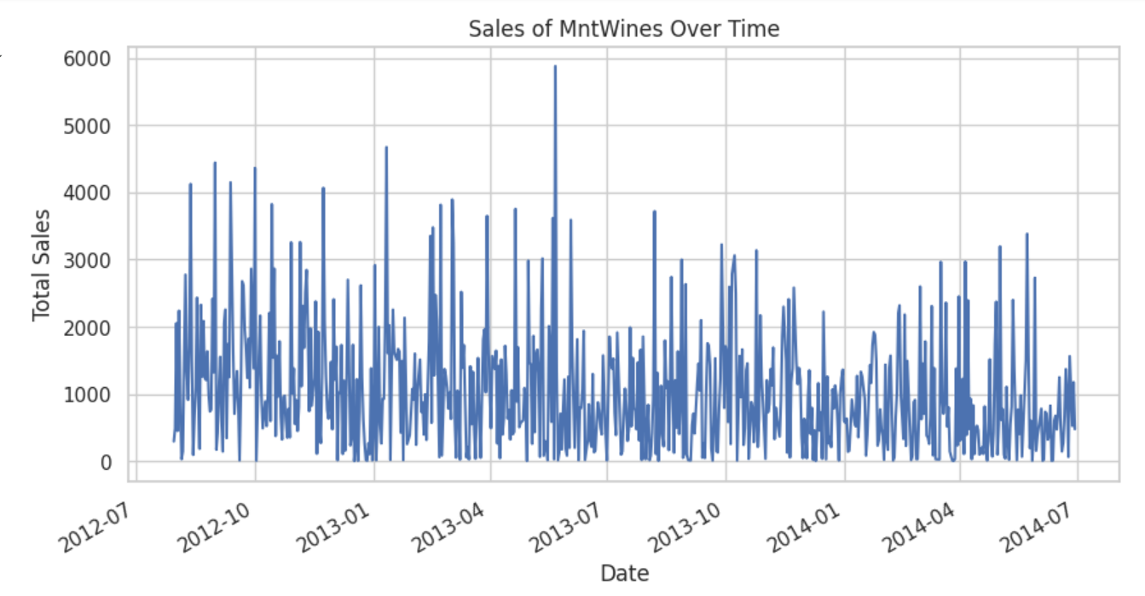

4.8 Violin Plot
sns.violinplot(x='Education', y='Income', data=df)
plt.title("Income Distribution by Education Level")
plt.xlabel("Education")
plt.ylabel("Income")
plt.xticks(rotation=45)
plt.show()
plt.show()

This code generates a violin plot to visualize the distribution and density of Income across different Education levels, revealing variations and potential outliers within each group.
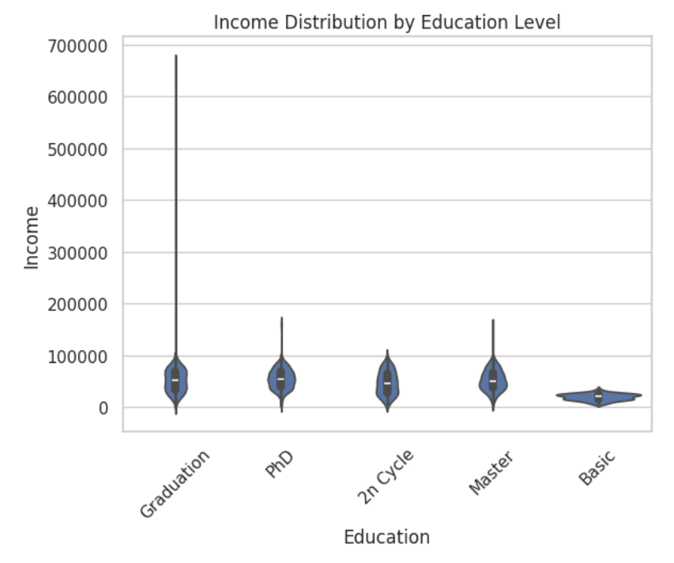
Result:

4.9 Stacked Bar Chart
if 'Country' in df.columns and 'Complain' in df.columns:
stacked = pd.crosstab(df['Country'], df['Complain'])
stacked.plot(kind='bar', stacked=True)
plt.title("Country-wise Complain Distribution")
plt.ylabel("Count"
plt.xticks(rotation=45)
plt.show()

This code generates a stacked bar chart showing the distribution of complaint status across countries, helping to compare how customer complaints vary by region.
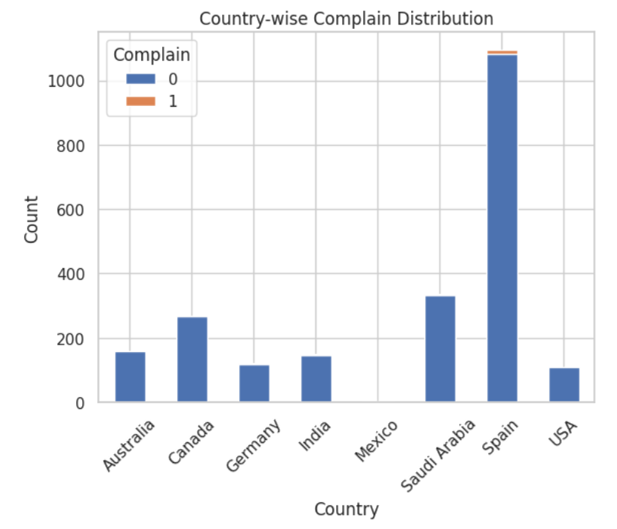
Result:

Part E: Use of Git

5. Git Setup

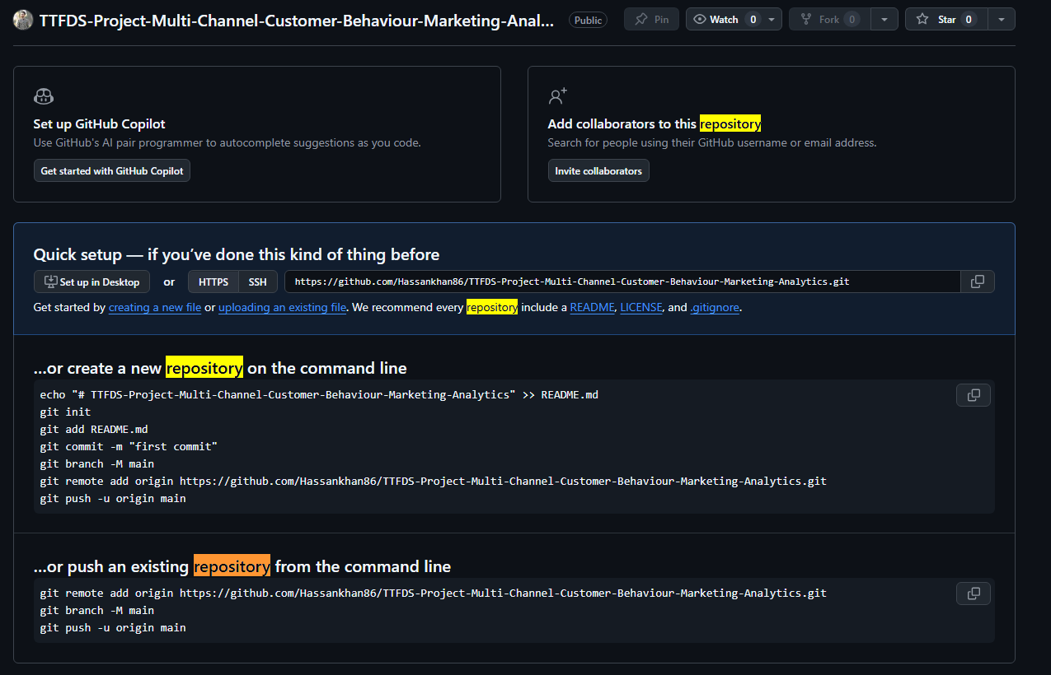
5.1 Repository created

5.2 Initializes a new local Git repository in your current folder
Initializes a new local Git repository in your current folder.
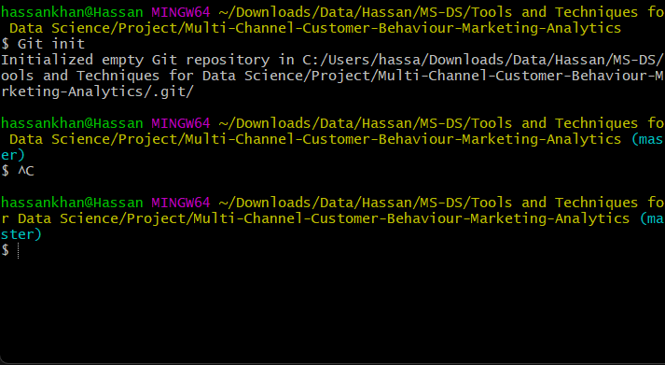

5.3 Git add/commit
- Git Add: Moves files into the staging area (preparing for commit
- Git Commit: Saves your staged changes into Git history with a descriptive message.
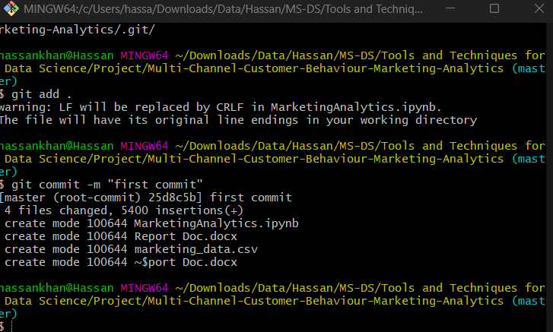

5.4 Git remote add origin
Cmd: Git remote add origin https://github.com/Hassankhan86/TTFDS-Project-Multi-Channel-Customer-Behaviour-Marketing-Analytics.git
Connect your local project to a remote repository (only needed once).
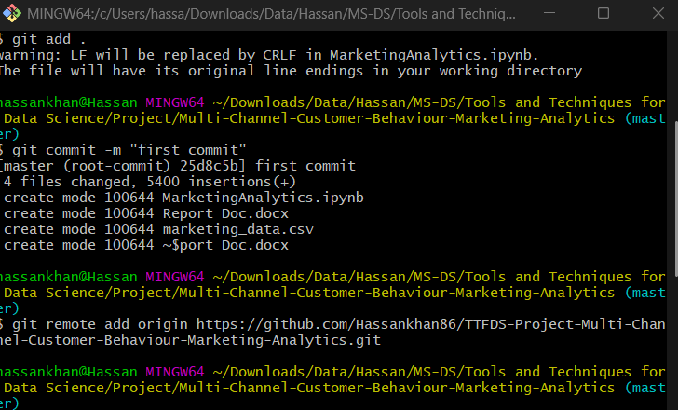

5.5 Git push
Uploads commits from your local branch to the remote branch.
- First-time push for a branch: git push --set-upstream origin master
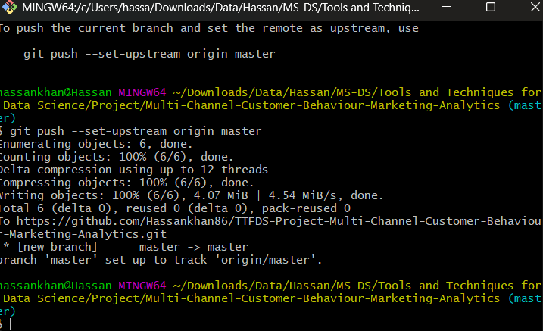

5.6 Link to the Git Repo
Link: https://github.com/Hassankhan86/TTFDS-Project-Multi-Channel-Customer-Behaviour-Marketing-Analytics

Part F: Use of ML techniques

6. Use of Machine Learning Techniques
Develop two models using suitable data mining algorithms

6.1 Import Libraries
from sklearn.model_selection import train_test_split
from sklearn.preprocessing import StandardScaler
from sklearn.linear_model import LogisticRegression
from sklearn.ensemble import RandomForestClassifier
from sklearn.metrics import classification_report, confusion_matrix, accuracy_score

6.2 Upload the Dataset
df = pd.read_csv("marketing_data.csv")
df.head()

In this step, essential Python libraries were imported, and the marketing dataset was loaded using pandas. This provided the foundation for further data preprocessing, exploration, and modeling.

6.3 Data Preprocessing
df.columns = df.columns.str.strip()
df['Age'] = 2024 - df['Year_Birth']
features = [
'Income', 'Age', 'Kidhome', 'Teenhome',
'MntWines', 'MntMeatProducts', 'MntGoldProds',
'NumWebPurchases', 'NumStorePurchases'

df_model = df[features + ['Response']].dropna() # Drop rows with missing values
df_model.head()

In this step, the dataset was cleaned and prepared for modeling. Missing values were handled by dropping incomplete rows, and new features such as Age were created from the birth year. Only relevant variables were selected to keep the analysis simple and focused. The data was then split into training and testing sets for model building.

6.4 Split Data into Train/Test Sets
X = df_model[features]
y = df_model['Response']
X_train, X_test, y_train, y_test = train_test_split(X, y, test_size=0.2, random_state=42)
scaler = StandardScaler()
X_train_scaled = scaler.fit_transform(X_train)
X_test_scaled = scaler.transform(X_test)

To evaluate model performance, the dataset was divided into training and testing sets using an 80-20 split. The training set was used to build the models, while the testing set helped assess how well the models generalized to unseen data. Feature scaling was also applied to standardize the input variables where necessary.

6.5. Train Logistic Regression Model
lr = LogisticRegression()
lr.fit(X_train_scaled, y_train)

y_pred_lr = lr.predict(X_test_scaled)

print("Logistic Regression Report:")
print(classification_report(y_test, y_pred_lr))

A Logistic Regression model was trained using the standardized training data to predict customer responses. This algorithm was chosen for its simplicity and interpretability in binary classification tasks. The model performed well in predicting non-responders but struggled to identify actual responders, as shown by its low recall and F1-score for class 1. Overall, it served as a useful baseline for comparison with more complex models.
Result:
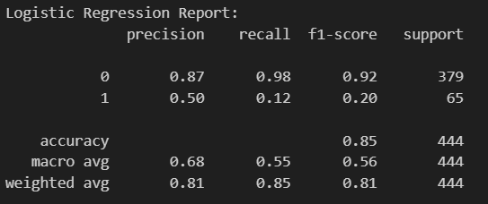

6.6. Train Random Forest Classifier
rf = RandomForestClassifier(random_state=42)
rf.fit(X_train, y_train)
y_pred_rf = rf.predict(X_test)
print("Random Forest Classifier Report:")
print(classification_report(y_test, y_pred_rf))

A Random Forest Classifier was trained on the same dataset to improve prediction performance. This ensemble method combines multiple decision trees and is well-suited for handling complex, non-linear relationships in the data. Compared to Logistic Regression, it showed better results in identifying actual responders, with higher recall and F1-score for class 1. The model also maintained strong overall accuracy, making it a more effective choice for this classification task.
Result:
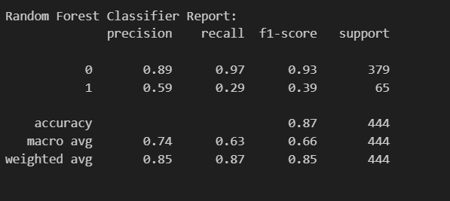

6.7 Analyse the results and provide a comparative evaluation using different data mining and visualization methods.

6.7.1 Accuracy comparison
accuracy_lr = accuracy_score(y_test, y_pred_lr)
accuracy_rf = accuracy_score(y_test, y_pred_rf)

plt.bar(['Logistic Regression', 'Random Forest'], [accuracy_lr, accuracy_rf], color=['skyblue', 'orange'])
plt.ylabel('Accuracy')
plt.title('Model Accuracy Comparison')
plt.ylim(0, 1)
plt.show()

1. Overall Accuracy
- Logistic Regression Accuracy: 85%
- Random Forest Accuracy: 87%
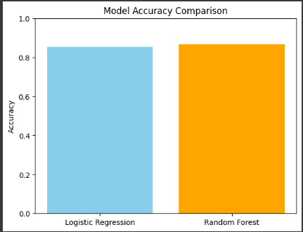
Random Forest performs slightly better overall.

2. Class-wise Performance
Class 0: Customers who did not respond
- Logistic Regression F1-score: 0.92
- Random Forest F1-score: 0.93
Both models are very good at predicting non-responders.
Class 1: Customers who did respond (key target)
- Logistic Regression F1-score: 0.20
- Random Forest F1-score: 0.39
Random Forest almost doubles the F1-score for responders — still not perfect, but much better.

3. Precision vs. Recall for Class 1
- Logistic Regression Recall: 0.12 → Caught only 12% of actual responders
- Random Forest Recall: 0.29 → Caught 29% of actual responders
Random Forest is clearly better at finding responders, which is the goal of targeted marketing.

4. Insights
- Logistic Regression is simple but struggles with the minority class (Response = 1).
- Random Forest performs better on both classes, especially in identifying responders.
This is expected, as ensemble methods like Random Forest handle class imbalance and non-linear patterns better.

Confusion Matrices

6.7.2 Logistic Regression Confusion Matrix:
fig, axs = plt.subplots(1, 2, figsize=(12, 5))
sns.heatmap(confusion_matrix(y_test, y_pred_lr), annot=True, fmt='d', cmap='Blues', ax=axs[0])
axs[0].set_title('Logistic Regression')
axs[0].set_xlabel('Predicted')
axs[0].set_ylabel('Actual')

- Correctly predicted non-responders (0): 371
- Correctly predicted responders (1): 8
- Missed responders: 57
This model struggles to catch responders — only 8 correctly identified out of 65.

6.7.3 Random Forest Confusion Matrix:
sns.heatmap(confusion_matrix(y_test, y_pred_rf), annot=True, fmt='d', cmap='Greens', ax=axs[1])
axs[1].set_title('Random Forest')
axs[1].set_xlabel('Predicted')
axs[1].set_ylabel('Actual')
plt.tight_layout()
plt.show()

- Correctly predicted non-responders (0): 366
- Correctly predicted responders (1): 19
- Missed responders: 46
Improved ability to detect responders — 19 out of 65 correctly identified.
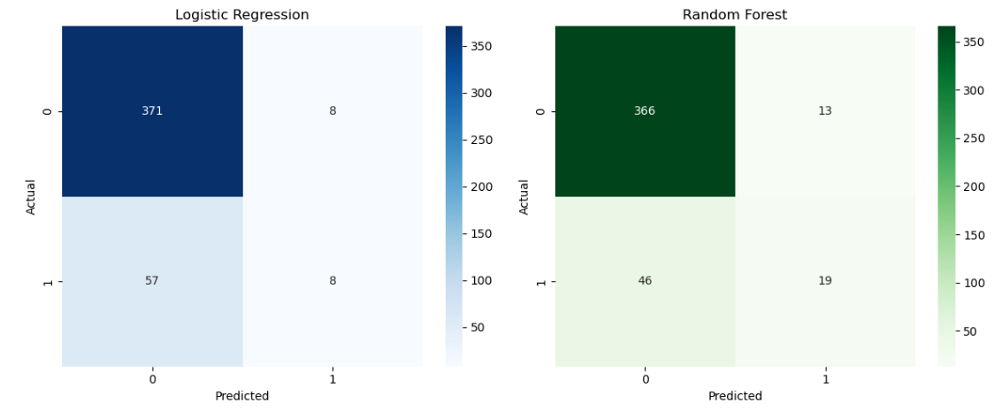
Conclusion:

The heatmaps clearly demonstrate that while both models predict non-responders well, Random Forest identifies more actual responders (19 vs. 8). This is crucial for marketing campaigns where identifying potential customers is more valuable than avoiding false positives.

Part G: Overall quality of the project

7. Quality of the project
This project demonstrates a complete and well-structured data analytics workflow, starting from data loading, cleaning, and exploratory analysis to advanced visualizations and predictive modelling. The dataset was carefully prepared through rigorous data wrangling steps, including handling missing values, removing duplicates, feature engineering, and transforming variables into a usable format. Comprehensive EDA was conducted to understand customer demographics, spending behaviour, and multi-channel interactions, and these insights were effectively visualized using a variety of charts with clear observations. The Power BI dashboard adds an interactive business intelligence layer, allowing stakeholders to explore customer segments, channel performance, and marketing campaign effectiveness in real time. Finally, machine learning models were implemented to predict customer response, enabling data-driven marketing decisions. Overall, the project delivers high analytical depth, meaningful business insights, and practical value aligned with the theme of “Multi-Channel Customer Behaviour & Marketing Analytics.”

